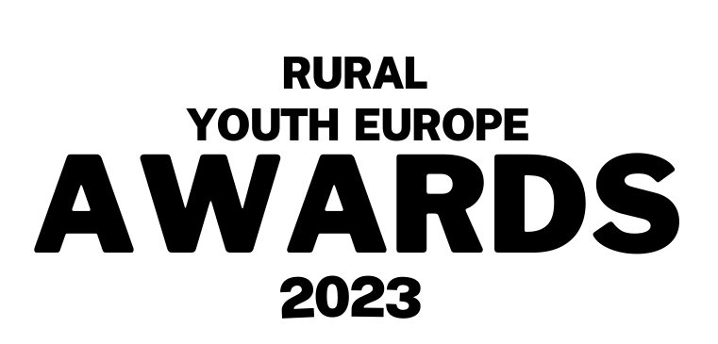


Submission Form
Inspirational Club of the Year 2023

Person/ Club name:
Name of organisation:
Contact person for the organisation (Name, email and phone number):

Description (max 400 words):
Write a short motivational/ introduction letter about why this club should be the inspirational club of the year 2023. What have the club achieved over the past year and what has been the impact of their work on young people and the local community?
Please make sure your application is in English.

Please send your completed application, alongside your photo(s) to communications@ruralyoutheurope.com.
All entries will be verified with member organisations before judging. The deadline for submissions is Friday 21st July.

