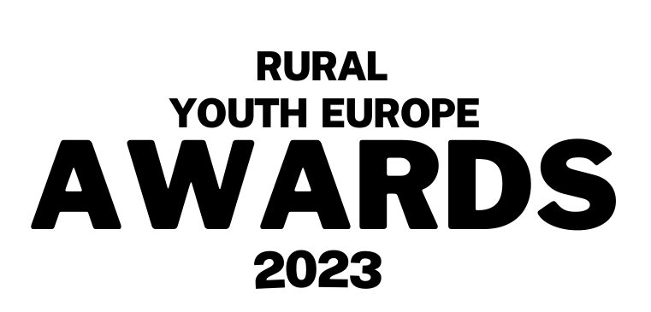


Submission Form
Inspirational Person of the Year 2023

Person/ Club name:
Name of organisation:
Contact person for the organisation (Name, email and phone number):

Description (max 400 words):
Write a short motivational/ introduction letter about why this person should be the inspirational person of the year 2023. What have they achieved over the past year and what has been the impact of their work?
Please make sure your application is in English.

Please send your completed application, alongside your photo(s) to communications@ruralyoutheurope.com.
All entries will be verified with member organisations before judging. The deadline for submissions is Friday 21st July.

