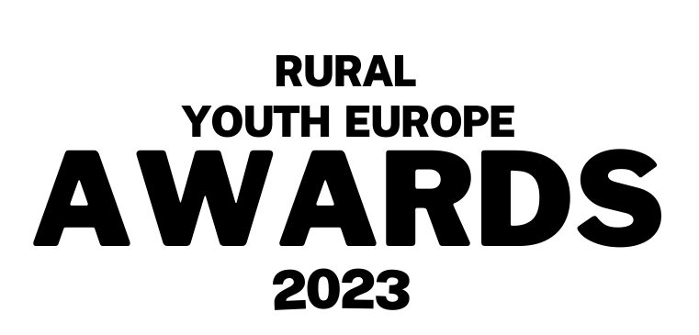
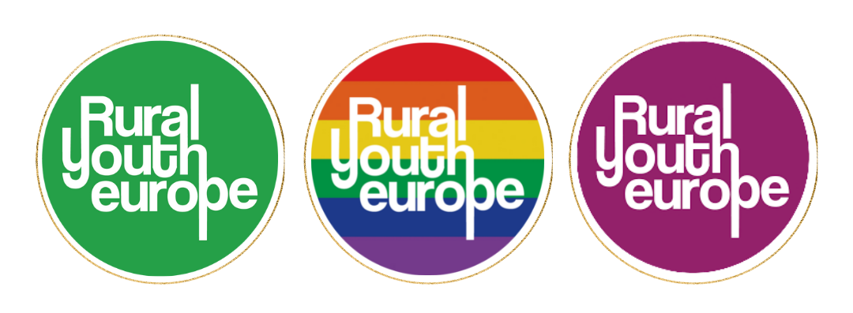

Submission Form
Rural Youth Project of the Year 2023
Project name:
Name of organisation:
Contact person for the project (Name, email and phone number):
Are at least half the team 18 years of age or younger? YES/NO
This category may be split between junior and senior categories at the judge’s discretion, depending on number of entries.
Project description Please make sure your application is in English - max 400 words.
- Why should your project be the Rural Youth Project of the year 2023?
- What was the goal?
- Where did the idea come from? Who was involved?
- What was the impact of this project on the community?
- How many people were involved in the project (approximately)

Please send your completed application, alongside your photo(s) direct to communications@ruralyoutheurope.com.
All entries will be verified with member organisations before judging. The deadline for submissions is Friday 21st July.

